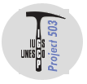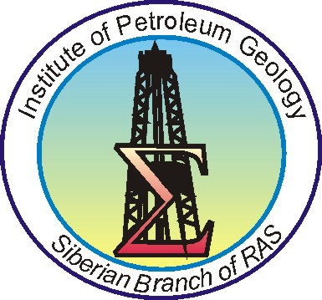
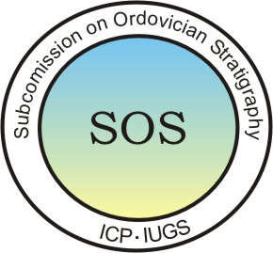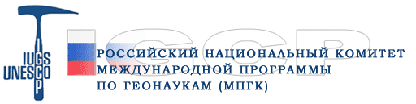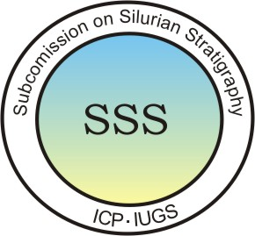

International conference
“Development of Early Paleozoic biodiversity:
role of biotic and abiotic factors, and event correlation”
(IGCP Project 503)
Moscow, Russia, 26 - 28 June, 2008
Altai, Russia, 30 June – 11 July, 2008 (post- conference field excursion)

Second Circular of Conference

Organizers
Paleontological Institute of the Russian Academy of Sciences (PIN RAS)
Siberian Branch of the Russian Academy of Sciences (SB RAS)
Institute of Petroleum Geology and Geophysics, SB RAS (IPGG SB RAS)
Interdepartmental Stratigraphic Committee of Russia (ISC)
IGCP Project 503 – "Ordovician Paleogeography and Paleoclimate"
Subcommission on the Ordovician Stratigraphy (SOS) of the International Commission on Stratigraphy
Subcommission on the Silurian Stratigraphy (SSS) of the International Commission on Stratigraphy

Sponsors
Russian Academy of Sciences
Presidium of the Siberian Branch of Russian Academy of Sciences
Russian Foundation for Basic Research (RFBR)
Scientific Research Program № 18 of the Presidium of RAS «The Origin and Evolution of the Biosphere»
Scientific Research Program № 11 “Biodiversity and Dynamic of Genetic Pools”
National IGCP Committee of Russia
Siberian Regional Interdepartmental Stratigraphic Committee (SRISC)

International Scientific Committee
S.V.Rozhnov, Co-Chairman | Paleontological Institute RAS, Moscow, Russia
N.V.Sennikov, Co-Chairman | Institute of Petroleum Geology and Geophysics, SB RAS, Novosibirsk, Russia
A.Achab | Canada
CHEN Xu | China
L.R.M.Cocks | UK
A.V.Dronov | Geological Institute RAS, Moscow, Russia
O.Fatka | Czech Republic
J.C.Gutierrez-Marco | Spain
D.A.T.Harper | Denmark
D.Kaljo | Estonia
A.V.Kanygin | IPGG, SB RAS, Novosibirsk, Russia
T.N.Koren | VSEGEI, St. Petersburg, Russia
A.Munnecke | Germany
A.W.Owen | UK
RONG Jiayu | China
T.Servais | France
P.M.Sheehan | USA

Organizing Committee
S.V. Rozhnov, Co-Chairman | Paleontological Institute RAS, Moscow
N.V. Sennikov, Co-Chairman | Institute of Petroleum Geology and Geophysics, SB RAS
V. Kushlina,  Scientific Secretary of conference | Paleontological Institute RAS, Moscow
O. Obut, Scientific Secretary of post-conference field-excursion | Institute of Petroleum Geology and Geophysics, SB RAS, Novosibirsk
A. Madison | Paleontological Institute RAS, Moscow
A.Pahnevich | Paleontological Institute RAS, Moscow
S. Nikolaeva | Paleontological Institute RAS, Moscow
O. Lebedev | Paleontological Institute RAS, Moscow

Three-day scientific program of the International conference “Development of Early Paleozoic Biodiversity: Role of Biotic and Abiotic Factors and Event Correlation”
- International Ordovician and Silurian Stratigraphic Scale
- Zonal scales and the problem of their correlation
- Bio- and sedimentary events
- Paleogeographic and paleoclimatologic reconstructions
- Evolution of taxonomic diversity
- Reconstruction of food chains and evolution of trophic structure of communities
- Sedimentary basins and environments
- Chemostratigraphy

Language
The official languages of the Conference are English and Russian.

Registration Fee
€ 200
Accommodation
Hotel in Moscow (breakfast included): € 85 per night, single room.

Social program
The excursions to the Moscow Kremlin, Armoury Chamber and Diamond Fund.

Second Circular of Post- conference field excursion
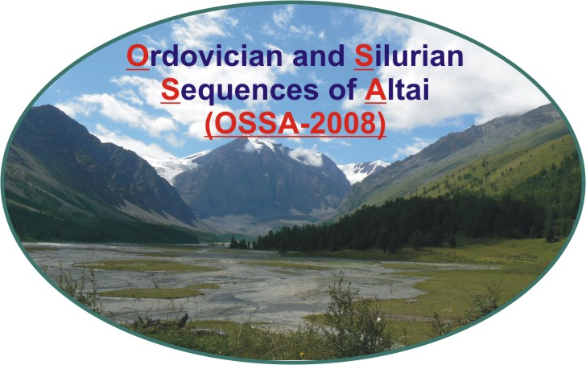
Ordovician-Silurian sequences
in the south of West Siberia
(Key sections and paleogeography, Gorny Altai)
(OSSA-2008)
June 30 – July 11, 2008

Organizers
Siberian Branch of the Russian Academy of Sciences (SB RAS)
Institute of Petroleum Geology and Geophysics, SB RAS (IPGG SB RAS)
Paleontological Institute of the Russian Academy of Sciences (PIN RAS)
Interdepartmental Stratigraphic Committee of Russia (ISC)
IGCP Project 503 – "Ordovician Paleogeography and Paleoclimate"
Subcommission on the Ordovician Stratigraphy (SOS) of the International Commission on Stratigraphy
Subcommission on the Silurian Stratigraphy (SSS) of the International Commission on Stratigraphy

Sponsors
Russian Academy of Sciences
Presidium of the Siberian Branch of Russian Academy of Sciences
Russian Foundation for Basic Research (RFBR)
Scientific Research Program № 18 of the Presidium of RAS «The Origin and Evolution of the
Biosphere»
National IGCP Committee of Russia
Siberian Regional Interdepartmental Stratigraphic Committee (SRISC)

Subjects emphasized in the conference and field trip:
- International Ordovician and Silurian Stratigraphic Scale
- Zonal scales and the problem of their correlation
- Bio- and sedimentary events
- Paleogeographic and paleoclimatologic reconstructions
- Sedimentary basins and environments

General schedule (dates are tentative and could be changed due to the Scientific Committee
members propositions)
29.06.08 Arrival in Novosibirsk, accommodation in the hotel, registration for excursion in the IPGG, brief introductory information.
30.06.08 – 11.07.08 Post-Conference Field Trip. Duration – 12 days.
12.07.08 – 13.07.08 Departure

Costs (in Euros)
Accommodation (hotel in Novosibirsk) about 60 Euro (per 1 night and reservation, without
breakfast)
Field excursion 575 Euro
Accommodation in field camps, field meals, transportation, guide book

Start of the Field excursion from Novosibirsk. Route from Novosibirsk to the first camp in the North-Western Altai is about 650 km.

Transport and food
For transportation in the field there will be the following vehicles: bus, 4WD tracks and jeeps.
Excursion costs including food supply (breakfast, lunch packages, dinner, beverages).

Clothing and field facilities
You are advised to bring your field boots, warm sweaters, raincoats, swimming suit, caps, hammer and others. Participants will be provided with tents, sleeping bags and other field gear. It is planned to stay in four field camps during the excursion, with distances between camps about 250-450 km.

Weather conditions
Novosibirsk is situated in the southern part of West Siberia E89 N55. Typical temperatures in the Gorny Altai are about +20-25⁰ C (day), rarely +30⁰ C, and +5-15⁰ (night). Occasional rain is possible. Heavy dew on the grass in the morning.

Geographical settings
Low and medium high mountains, taiga, mountain meadows. Exposures are along the river banks, on the slopes and tops of hills and mountains, in trenches and quarries.

Geochronology
All Ordovician and Silurian stages.

Age of most Ordovician stages is dated mainly by graptolites and rarely by conodonts.
Ordovician regional stages (in Russian terminology – horizons) in Altai are established on the basis of graptolites, trilobites and brachiopods.
As to Silurian stages, Rhuddanian, Aeronian, Telychian and Sheinwoodian stages are recognized mainly by graptolites, and in less by conodonts, Homerian and Ludlowian and Pridolian – mainly by trilobites and brachiopods, with few conodonts.
Silurian regional stages (in Russian terminology – horizons) in Altai are established on the basis of graptolites, trilobites and brachiopods.

Sedimentary types
- Oceanic
- Shelf
Rocks:
- siliceous-terrigenous,
- terrigenous,
- carbonate-terrigenous,
- carbonate (including reefal)
Paleogeographycal zones:
- near-shore, including rivers’ delta front,
- inner shelf,
- inner slope of the carbonate platform,
- central part and outer slope of the carbonate platform,
- deep-water shelf,
- continental slope.

Fossils
Graptolites, conodonts, chitinozoans, radiolarians, trilobites, brachiopods, gastropods, crinoids, scolecodons, tabulate and rugose corals, bryozoans, algae.

Cultural program
- Kolyvan’ stone working factory founded in 1802. World-famous giant ovoid vases from the Remnyov jaspers stored in Paris and Sankt-Petersburg (Hermitage) have been produced there at the beginning of 19 century. In XX century they have created the mosaic panels decorated Novosibirsk subway stations.
- Archeological monuments reflected history of ancient Siberian tribes:
  - The Denisova Cave in the Anui River valley is one of the most ancient dwelling places of humans in the Altai Mountains (more than 200 thousand years). It is believed to be evidence for the occupation of this territory by early Homo sapiens.
  - Scythians burial mounds. New ways of living and production – nomadic and semi-nomadic cattle breeding become wide-spread at the middle of the 1st millennia B.C. on the vast territories from Carpathians to Pacific Ocean. Thus, the early Iron Age or epoch of early nomads has began. These Indo-Europeans-nomads spoken one of the ancient Iranian languages were called Scythians. Most of them lived in Trans-Urals. Unique artifacts of Scythian culture were discovered from the burial mounds in the Gorny Altai. Among them Pazyryk cultural heritage (IV-III centuries B.C.).
- Teletskoe Lake (“Ataian Baikal”), boat trip. In shape, water and air cleanness Teletskoe Lake resembles Baikal. Extension of the lake is 70 km, its area - 22 300 hectare, with maximum depths 325 m. Altitude is 436 m.

Medical Care
The participants should have health insurance for the journey. All foreign participants are required to bring with them health insurance contracts, for the time of the trip, from the insurance company that provide international insurance policy program. This information can be obtained from your travel agency. There will be first aid in Novosibirsk, then Barnaul and Gorno-Altaisk. You should take along necessary medicine.

Travel and visa information
The Organizing Committee requires about 1,5 month for preparation of the Invitation Letter to obtain VISA and time for posting it by surface mail. Originals of the Invitation Letters will be sent by air-mail in the first half of May.
The participants can get to Novosibirsk directly after the Conference in Moscow (there are several flights a day from Moscow to Novosibirsk), or in case they will participate only in the Field excursion - flight directly to Novosibirsk via Frankfurt am Mine, Hanover, Beijing, Moscow, Sankt Petersburg and Seoul.

The Third circular with the additional information on the meeting and iternary of the field excursion will be sent in April.

Contact address for the conference:
Rozhnov, Sergey: Rozhnov@paleo.ru
Kushlina, Veronica: vkush@paleo.ru
Paleontological Institute RAS
Profsoyuznaya ul., 123
Moscow, 117997
Russia
Tel. +7 (495) 339 9888, 339 0822
Fax +7 (495) 339 1266

Contact address for the post-conference excursion:
Obut, Olga: ObutOT@ipgg.nsc.ru
Institute of Petroleum Geology and Geophysics, SB RAS
Acad. Koptuyg av., 3
Novosibirsk, 630090
Russia
Tel. +7 (383) 333 2431
Fax +7 (383) 333 2301

Contact address for all members of Organizing Committee: pz-conference@mail.ru

Registration form

International conference
“Development of Early Paleozoic biodiversity:
role of biotic and abiotic factors, and event correlation”
(IGCP Project 503), Moscow, Russia, 26 - 28 June, 2008

Post- conference field excursion in the Gorny Altai, Russia,
Ordovician-Silurian sequences
in the south of West Siberia
(Key sections and paleogeography, Gorny Altai)
(OSSA-2008), June 30 – July 11, 2008

Please complete and return by 1st April, 2008 by E-Mail to:
pz-conference@mail.ru (or vkush@paleo.ru ); ObutOT@ipgg.nsc.ru

First name: ……………………… Family Name: …..…..……………….……….
Sex: (M/F) ……….. …………………….
Institution: ………………………………………………………………………………..…
Address: ………..……………………….. City: ……………………………………..…..
State/Province: …………… Country: ………………… Postal code …………………...
Phone: ………………….. Fax:………………………. E-mail: ……………………….

Please indicate your participation:
in conference
possibly |  |  | probably |  |  | certainly
in field excursion
possibly |  |  | probably |  |  | certainly

I will submit:
Oral presentation

Author(s) and title(s): …………………………………………………......................................
……………………………………………………………………………………………….….
For your oral presentation please specify your requirements:
PowerPoint presentation |  |  | slide projector |  |  | overhead projector

Poster

Author(s) and title(s): …………………………………………………......................................
……………………………………………………………………………………………….….
Official invitation needed: | yes |  |  | no

I intend to be accompanied: | yes |  |  | no

Date

