Проекты МПГК 493 и 587: Рассвет и закат Вендской биоты (2003-2007 и 2010-2014)
Из книги Истории, заключенные в камне (40-летие Международной программы по геонаукам (МПГК)
ЮНЕСКО, 2012)

IGCP 493 and 587: The Rise and Fall of the Vendian Biota (2003-2007 and 2010-2014)
From the book Tales Set in Stone (40 Years of the International Geoscience Programme (IGCP)
UNESCO, 2012)

IGCP 493, which evolved into IGCP 587, dealt with the precise timing of global events during the late Proterozoic (older than about 543 million years) and the events changing the environments of that time (climates, global ocean and atmospheric chemistry and palaeogeography) had on the development and diversification of the Earth’s first animals, culminating in the spectacular and globally-recognized Ediacaran or Vendian faunas. That fauna did not look like modern animals. Some looked like a cross between an animal and a plant, others looked like Frisbees and others like worms, although they were not. Some were smaller than a finger nail, others larger than a meter. After that fauna went extinct, animals we are more familiar with (equipped with shells and eyes) arrived with the ‘Cambrian explosion’ (542 million years ago).

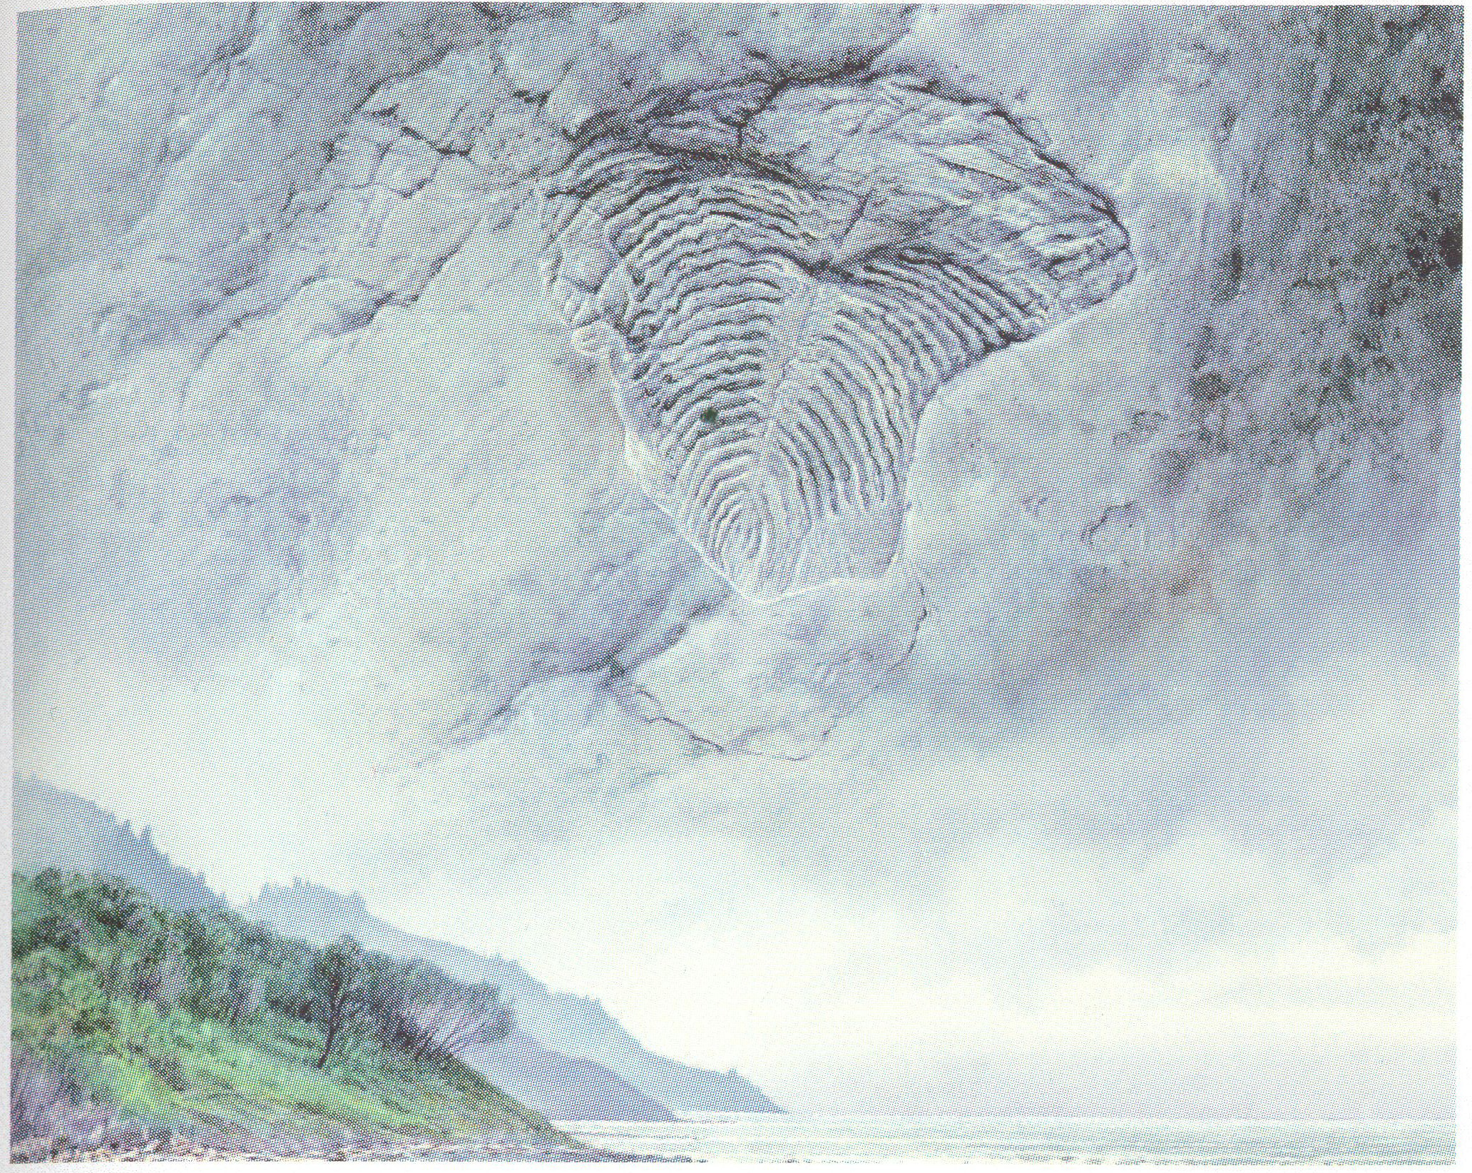
Imaginary Yorgia rising in the clouds above Zimni Gory on the White Sea coast of northern Russia, one of the locales intensively worked by members of the Precambrian Laboratory of the Palaeontological Institute, Russian Academy of Sciences, who were participants in IGCP 493. Art crafted for use in both publications and exhibitions.

© Peter Trusler

Ediacaran or Vendian biotas are best represented along the Winter Coast of the White Sea in the Russian Federation, in the Flinders Range of South Australia, in the southern deserts of Namibia, along the Yangtze River in China and in the coastal outcrops of Newfoundland in Canada. Other less biodiverse faunas from NW Canada, Siberia, the Ural Mountains in the central Russian Federation and in the Ukraine, Mongolia, NW Argentina and central Brazil and the Middle East have been investigated and they, along with the better known locales, have provided and continue to provide significant new information on the rise and demise of this unique Neoproterozoic metazoan assemblage (multicellular animals), which blossomed and prospered from around 600 to 543 years ago. Then, it disappeared rather abruptly, giving rise to only a few of the animal groups we know today. Working out what controlled the precise make-up of this globally-distributed multicellular assemblage (environments, time or both?) has been and continues to be, central to the activities of the researchers involved in studying these two multidisciplinary projects. Pushing the boundaries, both in expanding the known age-span of this Ediacaran or Vendian assemblage, as well, as understanding the detail of the morphology and functioning of the unique architecture of these strange first animals, has been a mange theme of these two IGCP projects.

Over the years, more than 110 researchers have been involved in IGCP 493 and 587 from a wide range of countries: Argentina, Australia, Brazil, Canada, China, the Czech Republic, Germany, India, Iran, Iraq,, Ireland, Italy, Japan, Namibia, the Netherlands, Poland, Russian Federation, Saudi Arabia, Spain, Sweden, South Africa, Taiwan of China, the UK, the USA, and Uruguay. These projects involved a multidisciplinary team of sedimentologists and stratigraphers, geochemists, geochronologists, structural geologists, palaeontologists, biochemists and functional morphologists, as well as a reconstruction artist, a significant number of undergraduate and graduate students, children, teachers and mdia documentary producers.
Meetings organized and sponsored by these projects have been both field-oriented (E.G. White Sea and Siberia in the Russian Federation, Namibia, Argentina) and also conference-presentation oriented, allied with international Geological Congress meetings in Italy (2004) and Norway (2008), with Australia to come in 2012. Some meetings have resulted in significant publications such as the Rise and Fall of the Ediacaran (Vendian) Biota, produced by the Geological Society of London in 2007 as Special Publication 287, aswell as both research and popular news items in Argentina, Australia, China, Japan, the Russian Federation and Taiwan of China.

Mikhail Fedonkin, Precambrian Laboratory, Palaeontological Institute and Director, Geological Institute, Russian Academy of Sciences, Moscow, Russia; Patricia Vickers-Rich, Palaeontology, School of Geosciences, Monash University, Melbourne, Victoria, Australia; Jim Gehling, Senior Research Scientist, Palaeontology, South Australian Museum, Adelaide, South Australia, Australia (IGCP 493 and 587); Guy Narbonne, Geological Sciences and Geological Engineering, Queen’s University, Kingston, Ontario, Canada (IGCP 587).

