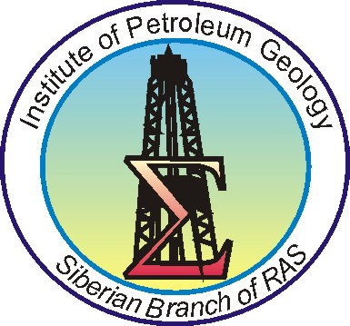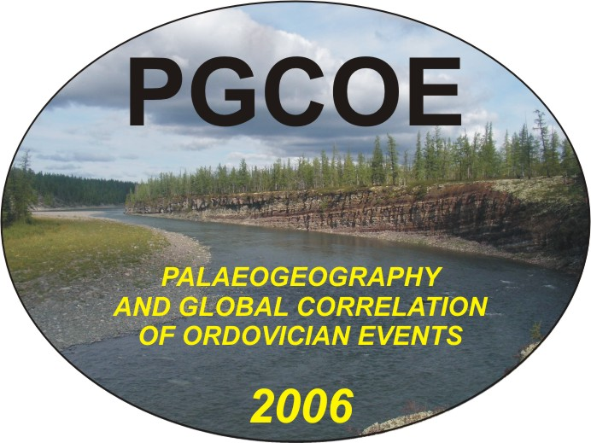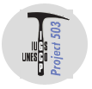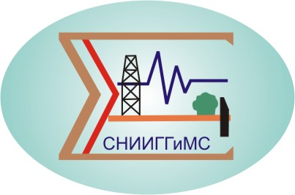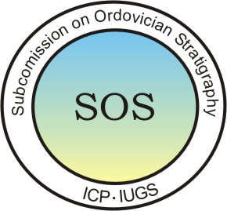

International Symposium
“Palaeogeography and Global Correlation of Ordovician Events” (“PGCOE”)”
(IGCP Project 503)
Novosibirsk, Russia, August 5 - August 8, 2006
Noril’sk, Russia, August 8 - August 16, 2006 (post-symposium field trip)

FIRST CIRCULAR

Organization
Siberian Branch of Russian Academy of Sciences (SB RAS)
Institute of Petroleum Geology, Russian Academy of Sciences, Siberian Branch (IPG SB RAS)
Paleontological Institute of Russian Academy of Science (PIN RAS)
Siberian Research Institute Geology, Geophysics & Mineral Resources (SRIGGMR)
Interdepartmental Stratigraphic Committee of Russia (ISC)
IGCP Project 503 – "Ordovician Palaeogeography and Palaeoclimate"
Subcommission on Ordovician Stratigraphy (SOS) of the International Commission on Stratigraphy

Co-Sponsorship
Russian Academy of Sciences
Presidium of the Siberian Branch of Russian Academy of Sciences
Russian Foundation for Basic Researches (RFBR)
Complex Scientific Program № 25 of the Presidium of Russian Academy of Science «The Origin and Evolution of Biosphere»
National IGCP Committee of Russia
National Committee of Russian Geologist
Siberian Regional Interdepartmental Stratigraphic Committee (SRISC)

Dear colleagues,
Herewith we would like to invite you to participate in the International Symposium “PALAEOGEOGRAPHY AND GLOBAL CORRELATION OF ORDOVICHIAN EVENTS” to be held on August, 5-8, 2006 in Novosibirsk at the Institute of Petroleum Geology, Siberian Branch of Russian Academy of Science. You are also welcome to take part in the pos-Symposium field trip to the north-west of Western Siberia platform (Kulyumbe River, 160 km off Noril’sk-city).
General schedule
04.08.06 Arrival in Novosibirsk, check-in at the hotel, registration with the IPG
05.08.06 – 07.08.06 Symposium proceedings
08.08.06 – 15.08.06 Post-symposium field trip
16.08.06 Departure from Noril’sk

Symposium Agenda
1. International Ordovician Stratigraphic Scale
2. Bio-/ sedimentary events
3. Palaeogeographic and paleoclimatologic reconstructions
4. Evolution of taxonomic diversity
5. Zonal scales and the problem of their correlation
6. Sedimentary basins and environments

- PGCOE Symposium languages – English and Russian

- 15-20 min. oral presentations are scheduled and poster materials planned to be introduced at the Symposium

Theses of both oral presentations and poster materials in Russian as well as in English have to be submitted by e-mail to the Symposium Organizing Committee not later than February, 15 2006 (not more than one A4 page – maximum two pages if the illustrations are included, with 2.5 cm margins). Other requirements for written presentations, such as Word for Windows, 12-pt Times New Roman type and 1.5 vertical spacing also should be taken into consideration. All the formulas, drawings, and tables are supposed to be integral parts of presentations. The report title (in capital letters) should be followed by authors’ names, properly marked and footnoted, if they come from different institutions, providing the information about each organization they represent (in small letters), such as the organization’s names and both their mail (with the post/ ZIP code) and e-mail addresses (in small letters, italic type). Please, underline the author(s)’ surname(s) and initials.
The abstracts of presentations and detailed field trip guide will have been published by the Symposium commencement date.
Within the framework of the Symposium there’s planned a post-symposium field trip on August, 8-15 onto the unique continuous carbonate succession of Lower, Middle and Upper series of Ordovician System on the Kulyumbe River (Siberian Platform). The succession on the Kulyumbe River to be shown therewith is well characterized by macrofauna and microfossils (trilobites, brachiopods, conodonts, graptolites, ostracods, crinoids, bryozoans etc.)

The registration fee per one participant is $ 100.

Field trip expenses amount to $ 1000 (the cost breakdown includes traveling by plane from Novosibirsk to Noril’sk, followed by helicopter transportation of the group(s) from Noril’sk to and from the Kulyumbe River field camp site (one way takes 50 min.)).

All potential participants of both the Symposium and pot-symposium events are requested to return the filled Registration Form (please, find enclosed) by e-mail to the Organizing Committee by 1st January 2006.

The Program Committee for the Symposium
A.V. Kanygin | Institute of Petroleum Geology & Geophysics SB RAS, Novosibirsk, Russia
S.V. Rozhnov | Paleontology Institute PAS, Moscow, Russia
A.I. Varlamov | Siberian Research Institute of Geology, Geophysics & Mineral Resources, Novosibirsk, Russia
N.V. Sennikov | Institute of Petroleum Geology SB RAS, Novosibirsk, Russia
I.V. Budnikov | Siberian Research Institute of Geology, Geophysics & Mineral Resources, Novosibirsk, Russia
Chen Xu | Nanjing Institute of Geology and Palaeontology, Academia Sinica, Nanjing, China
Servais Th. | Universite de Lille 1: Sciences de la Terre, Laboratoire de  Paleontologie et Paleogeographie du Paleozoique, France
T.N. Koren’ | All-Russian Geological Research Institute, St. Petersburg, Russia

Symposium Organizing Committee:
Alexander V. Kanygin (Organizing Co-chairman)
Sergey V. Rozhnov (Organizing Co-chairman)
Nikolay V. Sennikov (Organizing Committee Vice Chairman)
Alexander V. Timokhin (Organizing Committee Secretary)

Information for further contacts
- Contact persons
Alexander V. Kanygin (Organizing Committee Co-chairman)
Nikolay V. Sennikov (Organizing Committee Vice Chairman)
Alexander V. Timokhin (Organizing Committee Secretary)

Mail Address: Institute of Petroleum Geology & Geophysics SB RAS
3, Ac. Koptyug avenue, Novosibirsk, 630090, RUSSIA

E-mail: kanyginav@uiggm.nsc.ru Тел: (383)333-2901 Fax: (383)333-2301
E-mail: sennikovnv@uiggm.nsc.ru Тел: (383)330-8847 Fax: (383)333-2301
E-mail: timokhinav@uiggm.nsc.ru Тел: (383)333-2901 Fax: (383)333-2301

Sergey V. Rozhnov (Organizing Committee Co-chairman)
Mail Address: Paleontology Institute RAS
123, Profsoyuzhaya Str., Moscow, Moscow, 17647, RUSSIA
E-mail: rozhnov@paleo.ru Tel: (095)339-98-88 Fax: (095) 339-12-66

Internaional symposium
«Palaeogeography and global correlation of ordovician events»

Novosibirsk, RUSSIA August, 5 – 8 2005
followed by the fieldtrip onto the Ordovician succession on the Kulyumbe River
(in the north-west of Siberian platform) 8-15 August 2006

Advance Registration Form

Name/Surname: ……………..…..…………..
Organisation: ……………
Address: …………..…..
Tel.: Fax E-mail:

Please, mark the appropriate box:

I evaluate my possibility to participate as:

I, probably, will I’m likely to I will, definitely

The preferred form of presentation:

oral

poster

Provisional title of your report: …………………………………………………...
………………….…………………………………………………………………………………………………….

Participation in the field trip: yes I’m not sure no

Date:

Thank you for cooperation. We are looking forward to seeing you at the PGCOE Symposium!

With best regards,

Alexander V. Timokhin
Organising Committee Secretary

